**MINI PROJECT 2: PEER CRITIQUES**

For Mini Project 2, you will submit a revision/enhancement of your submission for Mini Project 1. To help facilitate this revision, you will participate in peer critiques: each student will be assigned to a small group (randomly assigned by Steven/Canvas), and within each small group, students will be asked to pair up and discuss/exchange projects for feedback.

**How this will work**

Steven has randomly broken the class into small groups. Your group can be found on Canvas under **People > Peer Review Groups: Mini Project 2**.

Within these groups, each student should pair up with one other student in the group. Within pairs, students should share the project they submitted for Mini Project 1 and offer/receive feedback on those projects (more information is given below). The pair may decide how to conduct this discussion based on what works best for each student: You may discuss your projects synchronously, e.g., via a Zoom meeting you schedule yourselves, or asynchronously, e.g., via email or Slack.

**Regardless of how you structure the discussion, each student will be asked to submit evidence of receiving (and giving) feedback on their projects.**

**Completing the critiques/reviews**

In your discussion, each student should do the following to provide an overview of their project:

* Provide an overview of the purpose of the project: What are the data? What is being visualized? Why are those data being visualized? What message is the project trying to convey?
* Provide a rationale for the visual design of the project: What kind of visualizations were chosen, and why were those kinds chosen? What visual encodings (e.g., position, size, color, shape) were chosen for which variables in the data, and why were these encodings chosen? How was the page designed, and why? How does the design of the page complement the design of the visualization, and vice versa?
* Describe at least one problem related to the visual design you’d like specific feedback on, e.g., something related to layout or aesthetics that you are feeling uncertain about
* Describe at least one problem related to the code you’d like specific feedback on, e.g., a functionality you don’t know how to implement through code
* Describe at least one other problem or aspect of your project you’d like specific feedback on (of your choice)

In this process, each student will fill out a feedback form that is exchanged with the other student in the pair to document the discussion. In this feedback form, the person receiving critique will fill out some questions, and the person giving critique will also respond to some questions.

**The critique/feedback form is provided on the next page and must be submitted as evidence of completing the peer review. This form will be submitted as part of Mini Project 2 for a total of 5 points.**

**PEER CRITIQUE FORM (5 POINTS)**

Please complete this form to document evidence of participating in peer critiques on your project. Once you are done, submit this completed form as part of your Mini Project 2 submission.

**Questions in blue should be filled out by the person receiving the critique on their project.** **Questions in red should be filled out by the person giving the critique on that project.**

…

**Your Name:** Matt Wolfinger

* **Reviewer’s Name:** May Yang

**Provide a short overview of the purpose of your project (to share with reviewer):** What are the data? What is being visualized? Why are those data being visualized (as opposed to other data)? What message is the project trying to convey?

The data are contained in a set complied by Nolan Conaway on Kaggle documenting 18,893 album reviews from online music publication Pitchfork, stretching from 1999 to 2017. The first visualization represents the average rating score (out of 10) given to each genre of album, sorted into a scatterplot. The x-axis represents the number of reviews and the y-axis represents the average overall score of the compiled reviews for that genre. I thought representing the data in that way could answer a question I raised concerning whether or not the critic base had a favorite genre that blinded their objective nature as critics. This first visualization conveys that is not the case, and that the scores level out over time as more reviews are written for that genre.

The second visualization represents the average ratings of each individual critic that has written at least 25 reviews for the publication. This was created in order to see if reviewers become more cynical with time. The message taken out of this states that that is more than often not the case, and that they are fairly objective.

The last visualization documents the relationship between an album’s overall score and whether or not it received the publication’s gold star of the “best new music” label. The goal here was to see if there was a correlation between increasing score and the frequency of the label, since there’s no real answer as to why they give an album this label. The message here seems to say that there is a correlation, but it’s impossible to tell if that’s the causation.

* **Reviewer’s Response: In its current form, to what extent is this project successful in conveying that intended message? Justify your response.**

[Reviewer’s response]

This project is aiming to present a data set in reviews of an album of music for an online publication. I can see your passion and deep interest in music. The first paragraph gave me a basic understanding and context of this data set. And I really love the idea to break down every column from the data and elaborate each one. Also, it is nice to see the reasons why you disregard some of the columns. In addition, it is helpful to show the overall process from getting the data to visualization so that I can clearly know the reasons why you do that and ways how you do that. Overall, the structure makes a lot of sense to me to help to get those interesting insights finally.

**Provide a rationale for the visual design of the project:** What kind of visualization was chosen, and why was this kind chosen? What visual encodings (e.g., position, size, color, shape) were chosen for which variables in the data, and why were these encodings chosen? How was the page designed, and why? How does the design of the page complement the design of the visualization, and vice versa?

I chose two scatter plots and one double histogram. The scatterplot made it easy to dot individual points to represent one genre and show the variety/leveling out with the frequency of reviews. The second did something similar, including a line of best fit in order to show the average stays fairly consistent as the number of reviews a critic has written increase. I chose a red and green color scheme for the visualizations to help a reader quickly identify the individual points of data and see the variety between the two types of variables with the double layered histogram. For that histogram, I made one transparent so you could see the overlap. The page was designed in a way to explain the process of manipulating the data first, and then delve into each individual data visualization that came as a result of that data manipulation.

I’d say the design complements the designs of the visualization by incorporating that red/green color scheme into the headings of sections and forming a visual color-coded correlation in the reader’s head. When designing the page, I chose to center the visualizations while letting the text float left in order to make it clear when those visualizations stand out and let the explanatory text for those stand out and explain to the reader that this is different than the content we’ve been reading and exploring so far. I also made sure to keep the font consistent between the visualizations and page design to keep things cohesive so it can be viewed as one large piece.

* **Reviewer’s Response: How effective is the visual design of the project in supporting the intended purpose of the project? Justify your response.**

[Reviewer’s response]

For the whole page, Matt used the color scheme consistently. And the structure is great and clear. The first visualization clearly showed the critics are very objective to give their score, the difference is not that easy to be compared between genres though. For the second diagram, it is great overall but I saw four name labels of some points and felt confused about it. (Maybe I am being nitty-picky here.) In all, this project conveys the intended message very effectively. You raised three different questions and then created three three diagrams to answer the question correspondingly.

**Describe at least one problem related to the visual design you’d like specific feedback on:**

I had a bit of trouble figuring out how to represent the list of variables in the page so it stood out against everything else. Making it bolded definitely helped, I may try to center it or change the color in this next modified version. I’m open to suggestions.

* **Reviewer’s Response: Provide feedback on the aspect of visual design described above.**

[Reviewer’s response]

I agreed with the idea that it is helpful to make it bolded or change the color. Adding a different background color or a border could also be another option.

**Describe at least one problem related to the code you’d like specific feedback on:**

I couldn’t figure out how to pad the page so the text doesn’t take up all of the window. Also, the last visualization’s sizing can get awkward and cut off when the window is sized a certain way.

* **Reviewer’s Response: Provide feedback on the aspect of code design described above.**

[Reviewer’s response]

First of all, I think it may be nicer if you could add larger left padding and right padding. Because from a UX designer's perspective, it is not friendly for users to read the sentence from left to right for a long line. Or maybe you could also try to use multiple columns to present text and images as well. For example, you can put text on the left side while placing the code chunk on the right. In terms of the image width, maybe you can try to use the percentage of the window, “width = 80%”, rather than the specific number like “width = 1000”.

**Describe at least one other problem related to your project you’d like specific feedback on:**

I had trouble figuring out how to end it. I like the ideas I pitch at the end if I were to take things further, but I’m having trouble articulating the overall lessons learned.

* **Reviewer’s Response: Provide feedback on the issue described above.**

[Reviewer’s response]

The Next steps section is wonderful. I think you did awesome work. Since you already showed a lot of interesting content above, maybe making some summary here is good too. But this is only my personal preference, I don’t think you have to do more other things.

* **Reviewer’s summary: Provide a minimum of three recommendations for how to improve the experience and quality of the project you are reviewing. These may be related to visual design, code design, or anything else. For each recommendation, explain why you are making that recommendation, linking it back to the intended message or purpose of the project as a whole.**

[Reviewer’s response]

Like I said, overall I love this project and I have to say there are so many things I learned from you even including some details which I think will apply for my own project. I hope you won’t mind it.

I also would like to share some of my thoughts with you. But again, it is just my feelings which are not that professional stuff.

1. Adding some left padding for the headings could be helpful so that they can have some space to breath. Otherwise, it gives me some pressure to read them.
2. I know that you care about the design consistency so that you used the same font and color scheme which is good for designers to think about. But from my point of view, sometimes, we don’t have to stick with the exact same styles. We may use another font or style or color if the function of text is very different from others. For example, the text “Nolan Conaway on Kaggle” is a hyperlink which we can click on and leads us to another page. But it is not so intuitive to be distinguished from other text unless I try to hover or click on it. It is not the unique color or font you used on this page. Another example would be the explotoraty text under each diagram. They are center-aligned. But the size and font are the same as the other body paragraph. So it may result in users losing their visual focal point. If these texts are not as important as other paragraphs, maybe you can try to decrease the size or use some other font with thin lines. Because the visual perception hierarchy is so important to convey information to our audience.
3. It is important to make all these elements left-aligned to make this webpage more clean and visually designed.

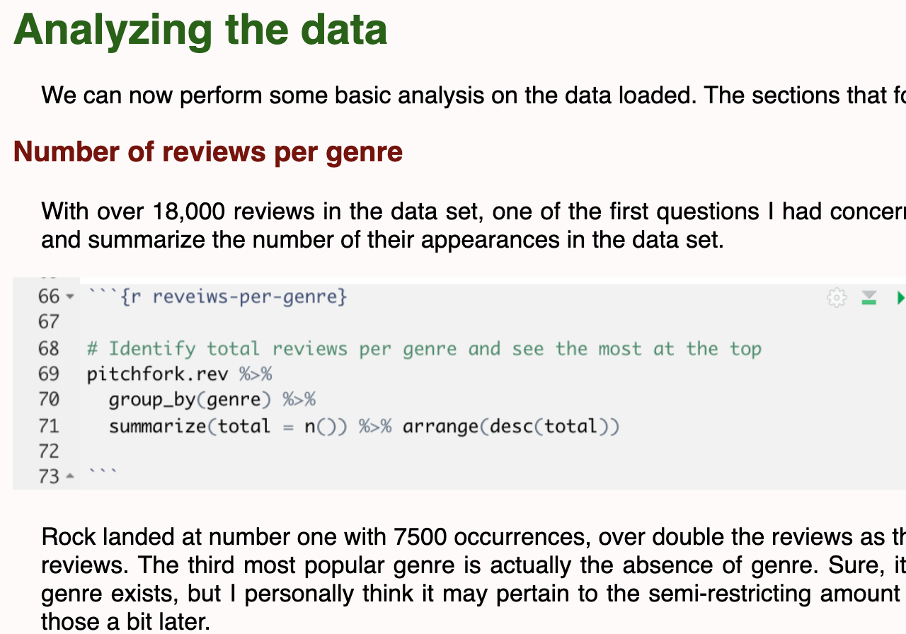

1. It is great if you can set the width of all images by percentage rather than a fixed number. so it won’t cut off when I open the page with a smaller window.

Except for these things, I want to say it is amazing again. And thanks for it!!! I will keep building on my own as well by absorbing new stuff from you!

**Recipient’s summary: After reflecting on the three recommendations provided by your reviewer above, respond to each recommendation in full. Do you agree with the recommendation? Why or why not? How will the feedback you received from your peer inform the revision of your Mini Project 2?**

[Enter your response]

…

Please use your reviewer’s feedback to consider how to improve your project prior to submission. You are not being asked to implement every recommendation your reviewer provides – instead, you are being asked to consider each recommendation, and whether or not you decide to accept a recommendation, you should have a clear justification for your decision.